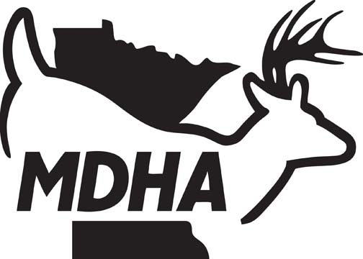
MINNESOTA DEER HUNTERS ASSOCIATION
460 PETERSON ROAD, GRAND RAPIDS, MN 55744
Phone: 1-800-450-DEER / Fax: 218-327-1349
www.mndeerhunters.com

Protecting the future of deer and deer hunting through Habitat, Education, Advocacy and Legislation

Board of County Commissioners
______ County
address
City, MN -
Dear Commissioners,
On behalf of the Minnesota Deer Hunters Association (MDHA), representing nearly 20,000 members and 60 local chapters across Minnesota, we write to express our strong support for the new statewide regulation allowing the use of hunting rifles during Minnesota’s deer season, beginning in 2026. We encourage (your County) County to fully align with this policy and not pursue any county-level restrictions that would limit hunters to shotgun use only.
This change reflects both modern hunting practices and Minnesota’s longstanding conservation values. Allowing rifles provides multiple benefits to hunters, landowners, and communities:
1. Safety and Accuracy
Rifles enable hunters to take more ethical and precise shots at responsible distances, reducing the risk of wounding deer and ensuring quick, clean harvests. This improves overall hunter safety and animal welfare.
2. Effective Deer Management
Meeting population goals set by the Minnesota DNR requires the most effective tools available. In areas with abundant deer populations, rifles allow hunters to play a stronger role in keeping herds balanced and healthy.
3. Hunter Retention and Participation
The tradition of deer hunting is central to Minnesota’s outdoor heritage. Providing hunters with the choice of rifles encourages broader participation, ensures more opportunities for success, and supports the economic impact hunting has on local businesses.
4. Consistency Across Minnesota
With the elimination of the shotgun-only zone, all hunters across the state will be operating under the same regulations. Keeping (County Name) County alignment with statewide policy prevents confusion, ensures fairness, and avoids unnecessary restrictions that could discourage participation.
MDHA believes this policy is a positive step forward for Minnesota hunters and wildlife management. We respectfully ask that (County Name) support this statewide regulation and resist efforts to reinstate shotgun-only rules at the county level.
Thank you for your leadership and your support of conservation and hunting traditions in Minnesota.
Respectfully,
MDHA Person’s Name
MDHA (office or chapter)
(Chapter Name) Chapter of the Minnesota Deer Hunters Association

